## Data Storytelling

This step is to explore the dataset to discover certain trends.

The goal of the exploratory data analysis was to find out whether a certain demographic is more likely to get approved compared to others.

The dataset was truncated to create a dataset centered around gender and education. In order to compare the demographics perfectly, different histograms were used to explore these newly-formed dataset.

Plotting graphs for different features includes repetitive line of codes, so to overcome this scenario different plotting functions were defined. These functions were called as per the need of visualization.

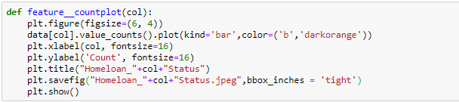

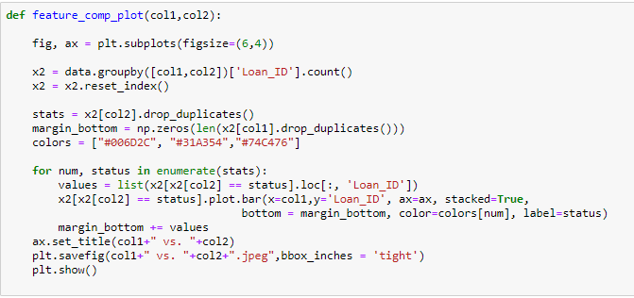

**Single Variable Analysis**

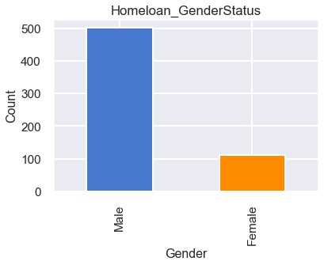

#### **Gender Column:**

According to our analysis, Gender may influence home loan approval. As we can conclude that, mortgage lenders were more inclined towards men than women expecting men to be the lead borrowers on single applications.

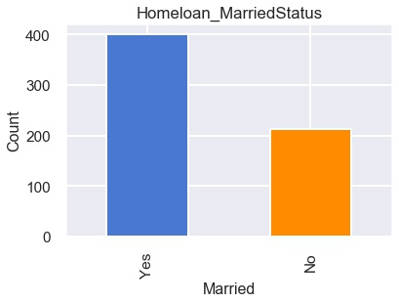

#### **Marital Status:**

From the above results, we can conclude that most of the home loans were approved to married couples compared to persons who are single or with no relationship.

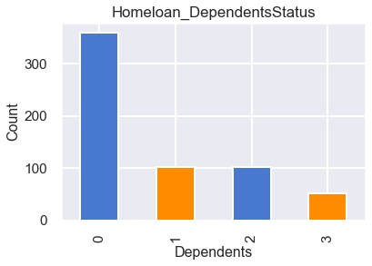

#### **Dependents:**

From the analysis, we can conclude that the number of dependents may automatically affected the approvals of home loans. There is a higher chance of getting home loan approval for applicants who have less number of dependents or no dependents.

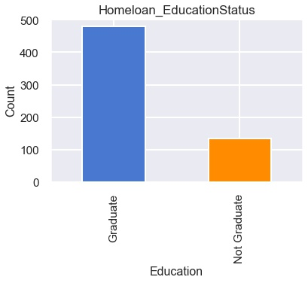

#### **Education:**

From the analysis, we can conclude that the educational status may automatically affect the approvals of home loans. There is a higher chance of getting home loan approval for applicants who are graduates.

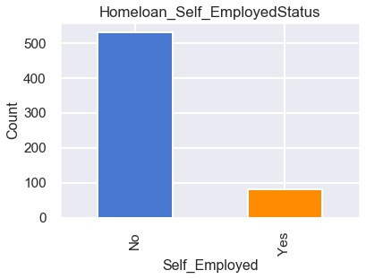

#### **Employment:**

From the analysis, we can conclude that the employment status may automatically affected the approvals of home loans. There is a higher chance of getting home loan approval for applicants who are self_employed.

**Multiple Variable Analysis**

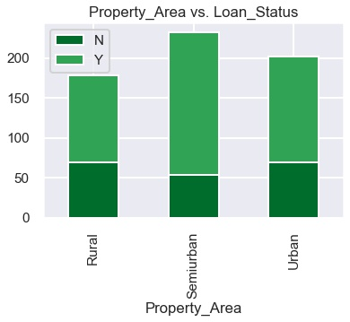

#### **Relationship between Property area and loan status:**

From the above results we can infer that the higher percentage of loan approval is for semi-urban houses followed by urban and rural houses.

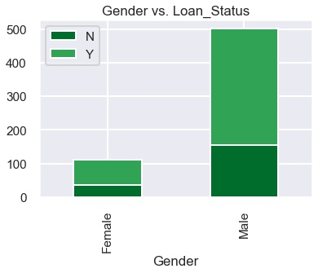

#### **Relationship between Gender and Loan status:**

From the data analysis, we can conclude that male gender as primary applicants have a higher percentage of loan approval than female as primary applicants.

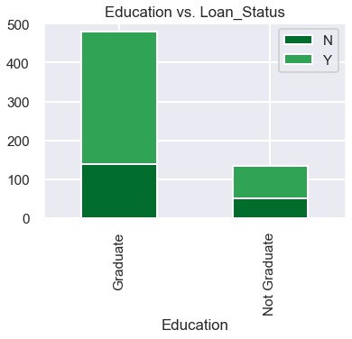

#### **Relationship between education vs Loan status:**

From the analysis, we can conclude that the applicants who are graduate were in a higher percentage of loan approval than non-graduate applicants.

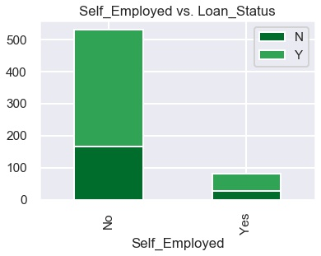

#### **Relationship between Self-Employed vs Loan_Status:**

From the data analysis, we can conclude that home-ownership rates for self-employed households were more declined than for salaried households.

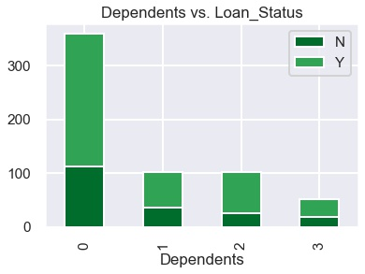

#### **Relationship between Dependents vs Loan status:**

From the analysis, we can conclude that the number of dependents may automatically affected the approvals of home loans. There is a higher chance of getting home loan approval for applicants who have less number of dependents or no dependents.

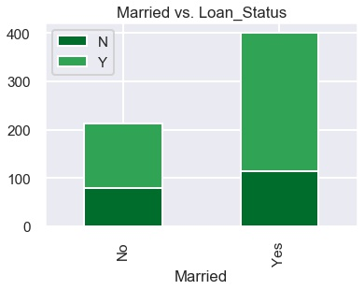

#### **Relationship between Marital status vs Loan status:**

From the analysis, we can conclude that the highest number of customers are married who were eligible for the home loan approval than single customers.

**Correlation Heatmap**

